Sprint Retrospective

Team reflection | Sprint backlog | User story and test description

Our team, Imagination Terraformers, had a very productive Sprint Three. Since this was our final sprint, we focused on the remaining game implementation and making small cosmetic changes to some of the screen layouts. We made this decision because after Sprint Two, we are much more comfortable with the technologies that we are using in the past two sprints. In order for the Sprint Three goals to be reached, we divided the work amongst our team to best suit our skillset. We worked through the challenges such as communication between Android Studio and Unity, level templates, question implementation, elevator functionality to move between levels, implementing load and save functionality into the Unity side of the game, and creating a pleasing experience for users. In the following paragraphs we will breakdown the roles of the sprint members so that there is a better understanding of what was done and how it was accomplished.

First to discuss is Austen’s contributions. Austen worked on functionality for levels and elevators, sprite design for NPCs, and the load and save functionality in the Unity side of the game so that the user may resume progress at a later time. He also added the boss sprite, and fixed the dialogue and question boxes. He played a large roll in game design and the work on the unity project.

Following Austen is Joseph. Joseph also played a huge role in this sprint. He implemented the level to elevator functionality for the game, refactored the unity design, and designed the layout for future levels to be built in Unity. He also implemented the badges and keycards for the game, spent time on level previews, and fixed the question answering errors that had previously occurred.

Sinead handled our sprint logs and documentation throughout the sprint. Along with this she also created a few activities for completion of the game and for the user to see what to expect from each level, implemented the emailing the user upon their completion of the game, and commented the new activities. She also worked on changing all of the backgrounds of the layouts and adjusting all text and input fields so that they remained visible to the user.

Finally, Gavin worked on passing information from android to unity using method calls instead of app to app communication, worked with Joseph to create two loading scenes in Unity that run start up scripts that he wrote and updated, and performed all testing of the project on his machine, which has the database set up on it.

Our team believes that we put in good work this project. We can utilize this experience to further gauge how much we can accomplish in a given sprint iteration for any future projects that we may work on. We were able to complete all the issues that we set out to accomplish this sprint and we have now completed the game – levels design, functionality, and all. No bugs remain in Hack Heist. Our team got the most work done when we all met together in person, which we had figured out last sprint. We hope that you enjoy your experience playing HackHeist, as much work was put into creating an interactive, user-friendly experience!

**Figure 1: Screenshots of Issues from Sprint 3**

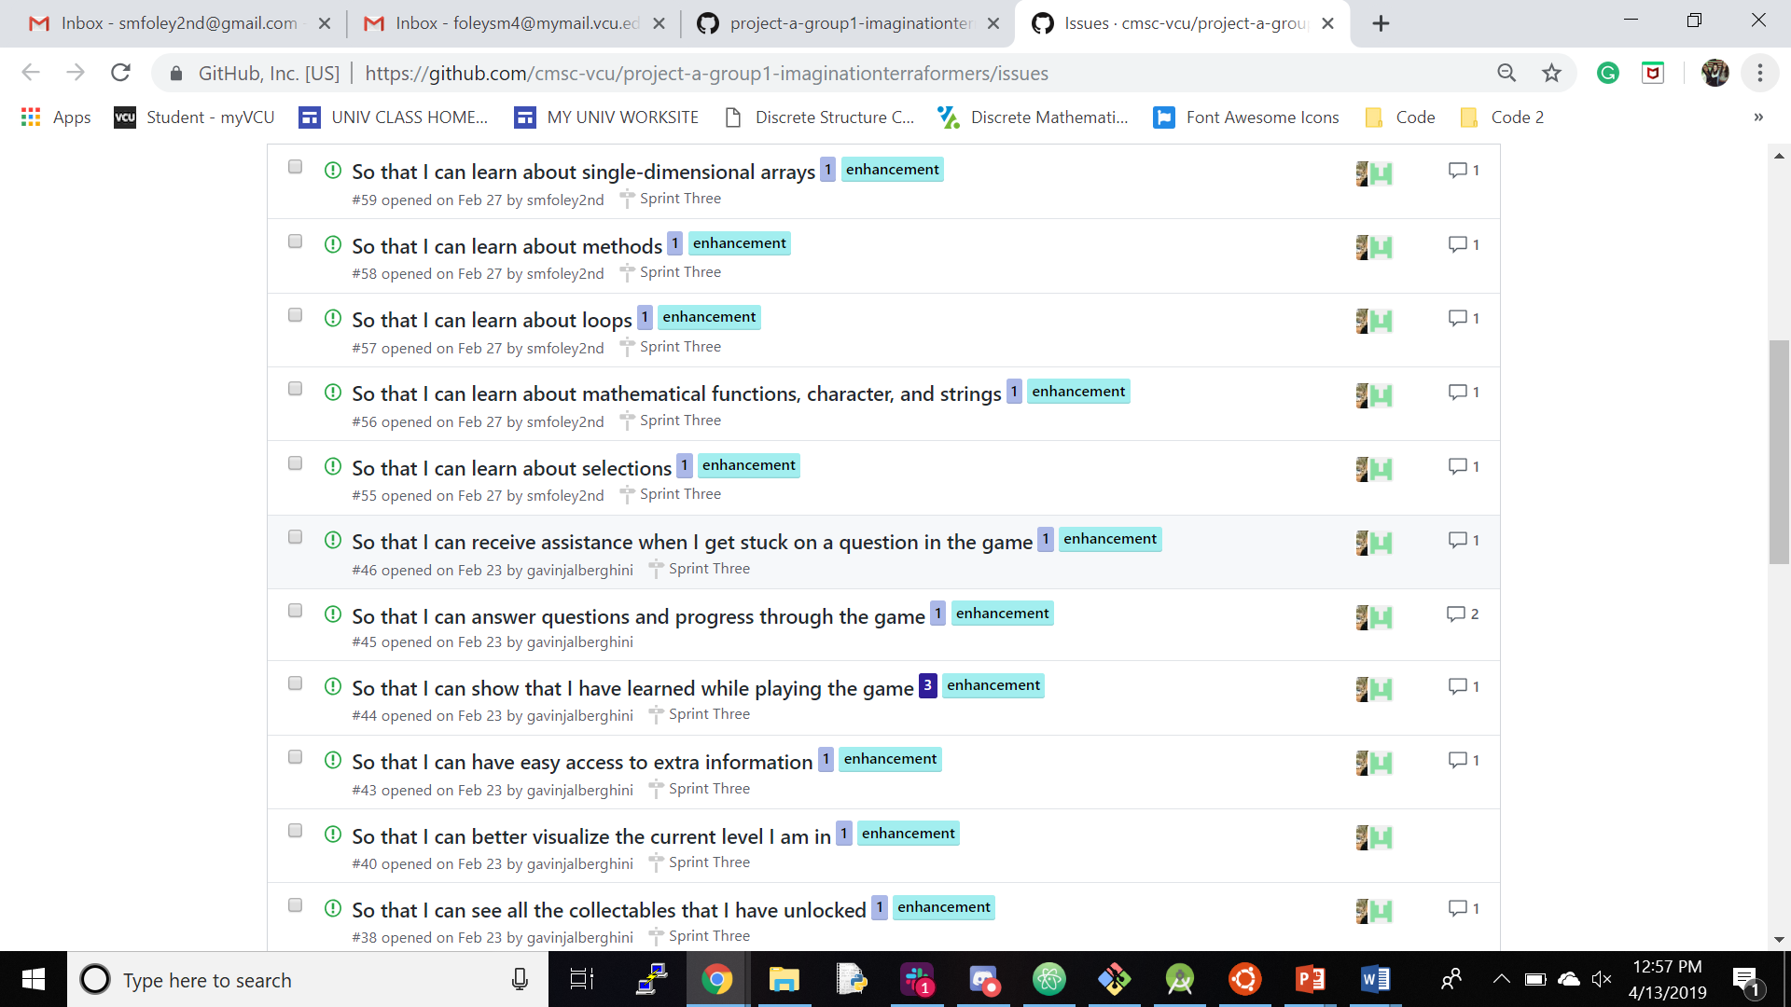

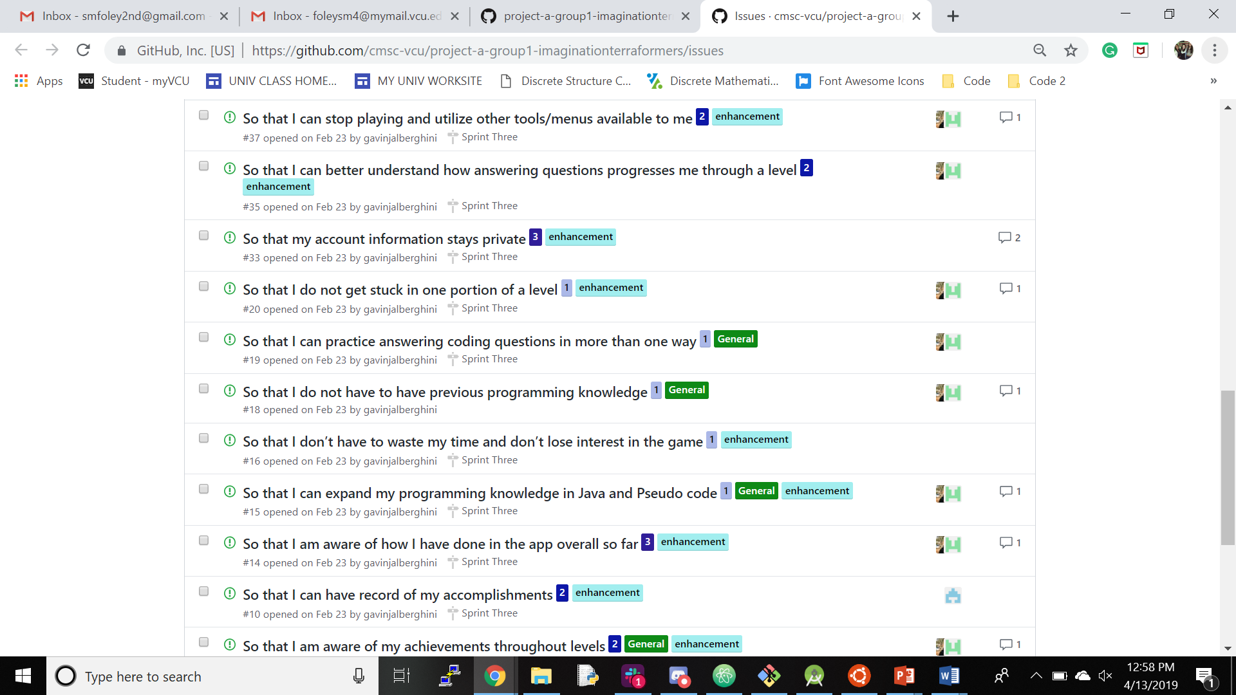

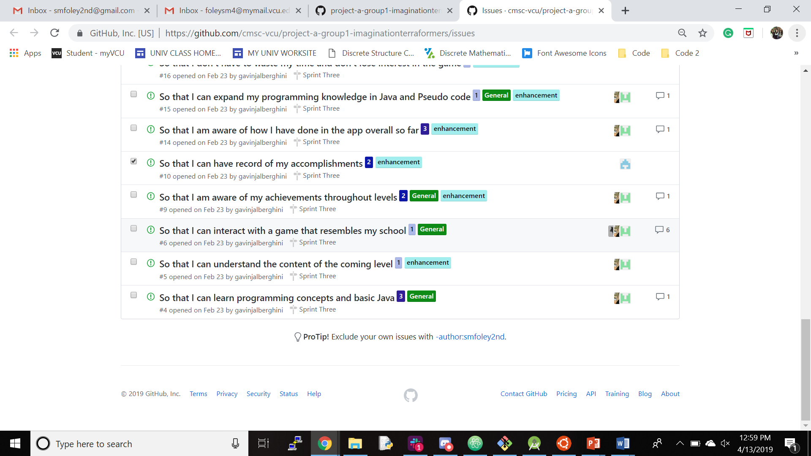

The figures above are screenshots of the GitHub issues page for our Repository. Each issue houses the entirety of the user story with elaboration in its description. All progress was reported in the form of comments by collaborators. In addition, all testing was commented on to each issue. In our project, testing is implemented in the ‘androidTest’ folder where each activity layout has a corresponding test class with tests that go over scrolling, button mapping, security, and all other forms of functionality for that given screen. For a more detailed explanation of test cases for each class, see the updated GitHub issues page. We were also told that we do not need to do tests for the Unity side of our project, which is what our main focus was in Sprint Two and Three.

The main issues that we encountered throughout this sprint were communication between Unity and Android, and having work that needed to be done for other classes and extracurricular activities. As a whole, we believe that we worked well as a team and we are very proud of our work.